An integrated semiconductor device enabling non-optical genome sequencing

Brief introduction to why this work is important

Basic biology background

Biology Background:

When a nucleotide is incorporated into DNA there is a release of hydrogen atoms. The release of the hydrogen atoms causes a change of pH. Solid state electronics have been studied to detect and measure the value of pH in a solution. PH is a measure of acidity or basicity of a solution.

Where aH+ is the molar concentration of protons in a solution.

When the hydrogen atoms are released they interact with the OH group of the metal oxide sensing layer, the dangling bonds.

ISFET History

Ion-sensitive field effect transistor (ISFET)

ISFET devices have been studied for many years. Proposed in 1969 (Development of an Ion-Sensitive Solid-State Device for Neurophysiological Measurements). The original design consisted of a silicon substrate, a source, a drain and an oxide sensing layer. The experiment consisted of providing a 100mV drain-to-source voltage and then measuring the drain current as a potential drop across a 10 ohm resistor connected in series.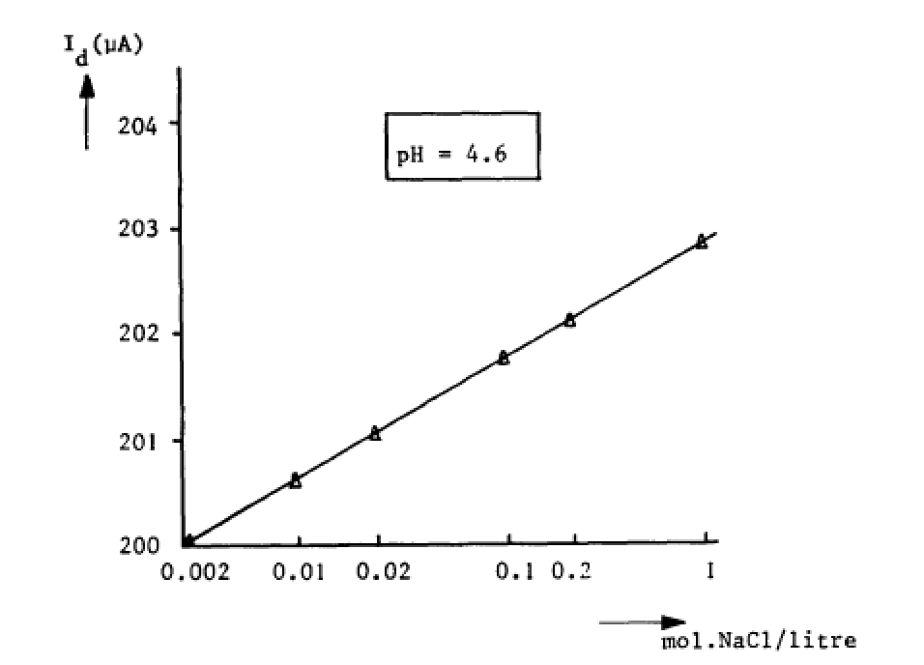

current device design

Single Unit:

The single unit devices presented here work on the same principles as the predecessors. Each single unit is indexed first through column selector and then through a row selector. With the introduction of a new reagent each of the sensors is indexed to measure the pH change in the well. If a nucleotide has been incorporated then the pH in the well would increase due to the liberation of hydrogen atoms. The liberation of hydrogen atoms leads to a change in charge on the oxide sensing layer which leads to a change in the drain current of the MOSFET below. The change in drain current can be then monitored with off chip circuitry to classify if a nucleotide has been incorporated or not.

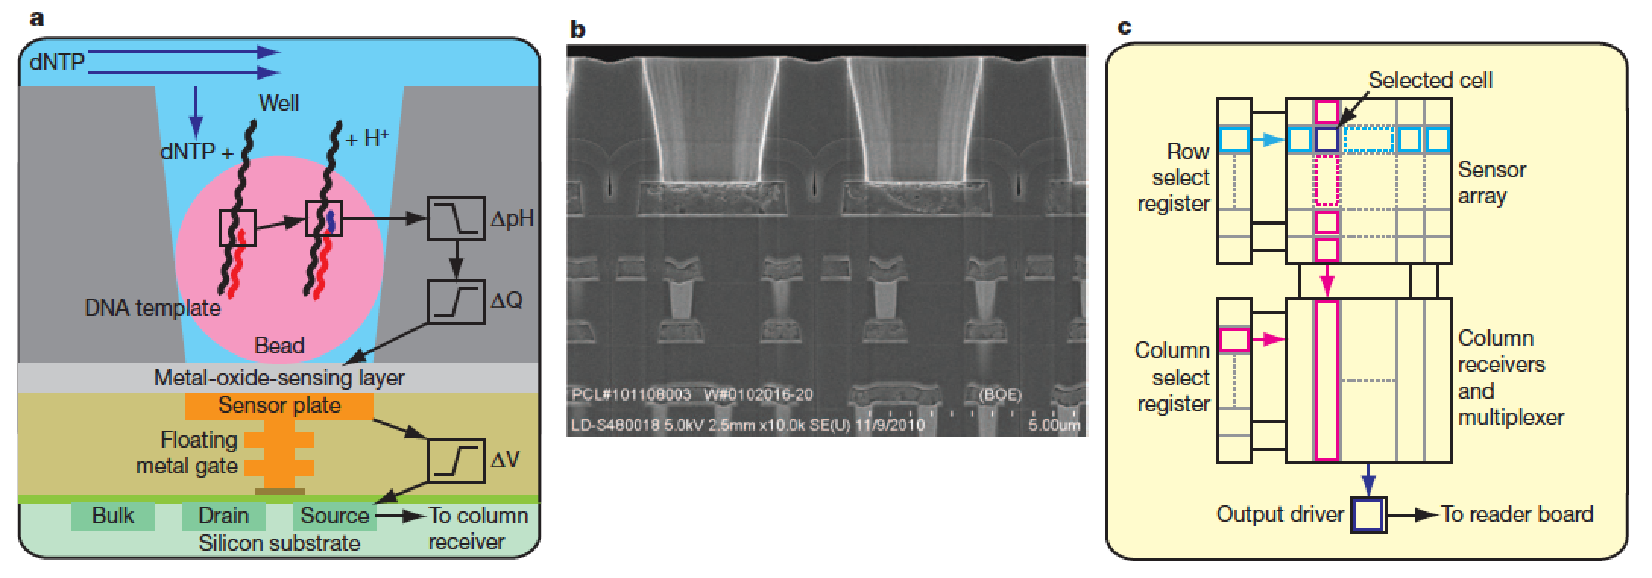

how it works

Sample Prep

bind DNA to micro bead

spin beads down into the reservoir

Flow reagents over

wait 4 seconds (show graph here)

calculate the total number of positives for each reagent

ph shift of .02

Wash reagents off

touch on how the well is cleaned in one-tenth sec

repeat

Sequence calling

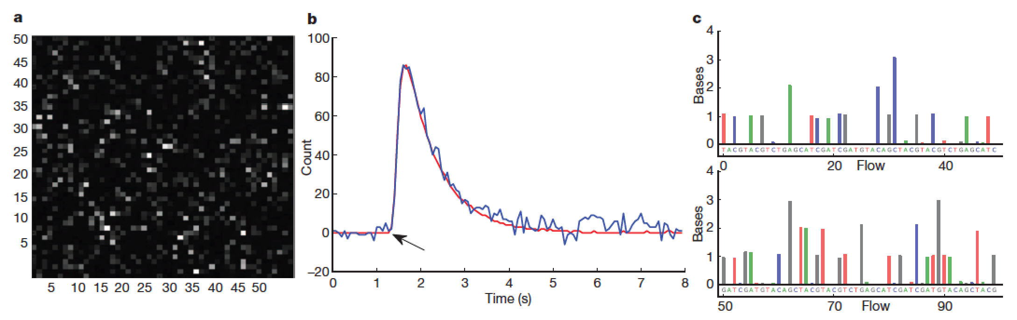

limitations of the device